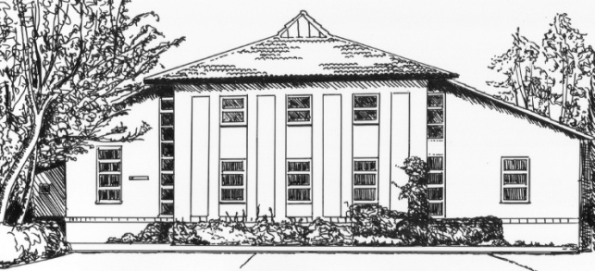
DR E V FEATHERSTONE
DR A B MALONEY
Dr K J BADHAM
Dr K BEALE
Dr M DEGNAN
Dr C CHRISTIE
DR H CLARKE
DR M GOUGH
DR Y OHLSSON

EASTFIELD HOUSE

6 ST JOHNS ROAD

NEWBURY
BERKSHIRE
RG14 7LW

TEL: (01635) 41495

FAX: (01635) 522751

www.eastfieldhousesurgery.co.uk

Eastfield House Surgery Newsletter – Autumn 2018

In this newsletter:
Patient Participation Group, Flu Jabs, Dr Miranda Gough
7 Day Working, Cancelling Your Appointment/DNAs,
Surgery Car Park, Surgery Opening Hours, Patient Contact Details

Patient Participation Group (PPG)
The last PPG meeting was held on 19th September at the surgery. The meeting was chaired by Dr Matthew Degnan and was, again, well attended. The meeting included a very interesting and informative talk on Lifestyle Medicine by Dr Yasmin Ohlsson.
A big thank you to the PPG who staged a performance of London Suite in July and raised £497 to buy some more chairs for the GP’s consulting rooms.
The PPG are planning to hold another coffee morning on Thursday 17th January at St Nicolas Church so please put the date in your diaries and come along to support us.
The full minutes of the meeting are available on the practice website or you can ask for a copy at reception.
The next meeting will be held on Thursday 17th January 2019 at 6.30pm. Everyone is welcome.

Flu Jabs
With Winter fast approaching, the flu season will soon be here. If you are in one of these groups you are entitled to a free NHS flu jab:
- All children 2 and 3 years old on 31/8/18
- Those aged 6 months to under 65 years in clinical risk groups
- Pregnant women
- Those with a BMI in excess of 40
- Those aged 65 years and over
- Carers
So, if you haven’t already had your flu jab, please contact reception to book an appointment.

Dr Miranda Gough
We are delighted to announce that Dr Gough gave birth to a healthy baby boy on 22/10/18. I am sure that Dr Gough’s patients will join us in sending congratulations to Dr Gough and her family.

7 Day Working
It is now possible for patients to book a routine face to face or telephone appointment between 6.30pm and 8.00 pm, Monday to Thursday, at any GP surgery in the Newbury area. Routine appointments can also be booked on a Friday evening between 6.30pm and 8.00pm and on Sunday morning between 8.00am and 12.00 with a GP at the West Berkshire Community Hospital.
These appointments can be booked via our reception team but for continuity of care, our GPs prefer that patients are seen by their own GP at Eastfield House whenever possible.
This new service is in addition to the West Call Out of Hours service.

Cancelling Your Appointment/DNAs
In the last 3 months 717 appointments at Eastfield House were wasted due to patients not turning up for their appointments and not cancelling them.

This means that more than 120 hours of clinical time was lost between August and October.

DNAs by month: August 2018 246
September 2018 200
October 2018 271

PLEASE IF YOU DON’T NEED YOUR APPOINTMENT CANCEL IT
Surgery Car Park
The SURGERY CAR PARK IS CLOSED to all patients before 4pm except those with a Blue Badge and those being dropped off or picked up by taxi. If you park in the car park without displaying a Blue Badge, you will be asked to move your car as you may be blocking a GP from going out on a visit or restricting access for an ambulance arriving to take someone to hospital.
Opening Hours
Our core opening hours are 8.00am to 6.30pm Monday to Friday. In addition we are open to 7.00pm on Tuesdays and Thursdays each week and on two Saturday mornings each month.
Please note: our phone lines are not open on a Saturday morning, so if you require urgent help on a Saturday morning please call 111 for advice or 999 in an emergency.
Don’t Forget to Update Your Contact Details

Please remember to let us know if you move, change your phone number or change your email address. It is important that we have your up to date details for when we need to contact you.

* * * * *

